Agroforestry Research Station, Jadua, Hajipur, Bihar
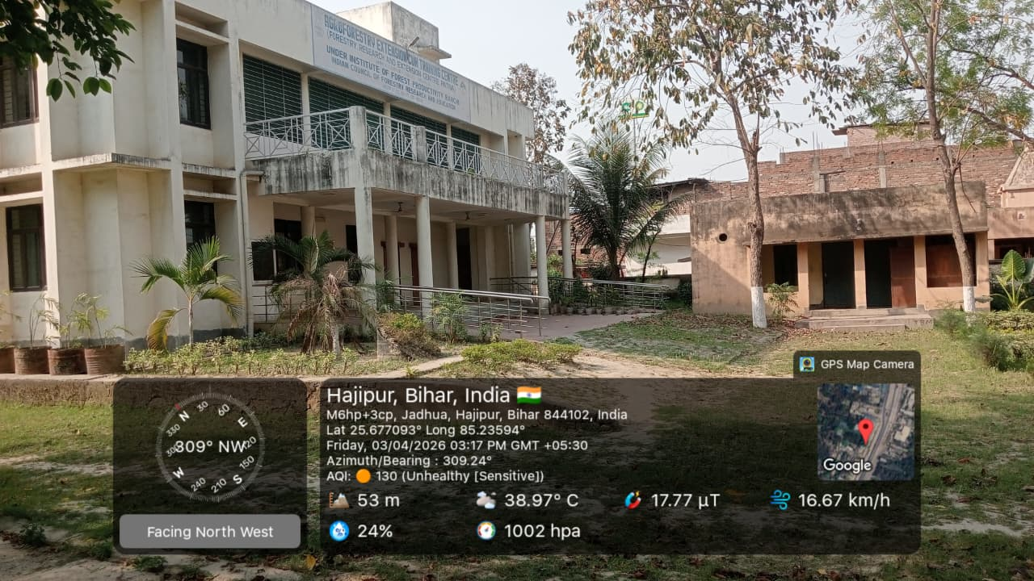

1. Introduction
The Agroforestry Research Station, Jadua, Hajipur in Vaishali district of Bihar is dedicated to agroforestry research, farmer training, and nursery development. Established with the objective of improving rural livelihoods through tree-based farming systems, the station plays a vital role in promoting sustainable land use practices in the region.

2. Historical Background
The station was established in 2006 over an area of 1.769 acres as Site-1 of the erstwhile Forestry Research and Extension Centre (FREC), Patna. At that time, FREC Patna operated through two primary sites along with several field stations across Vaishali district.
FREC Patna was created to implement the Community-Based Forest Management and Conservation Scheme, popularly known as the SASVPESY Project. The primary goal of this initiative was to enhance the income of farmers in Vaishali district by introducing agroforestry practices.
Under this project:
- Farmers were encouraged to adopt agroforestry systems.
- Special emphasis was given to planting fast-growing species like Poplar alongside traditional crops.
- Awareness and sensitization programs were conducted to promote tree-based farming.
Over time, the office building of FREC Patna was constructed at Site-1, leading to the emergence of FREC Hajipur as an operational unit.

3. Transition and Institutional Development
After the completion of the SASVPESY Project:
- Site-2 and associated field stations were transferred back to the Bihar Government Forest Department.
- Site-1 (Jadua Hajipur) was retained by ICFRE–Institute of Forest Productivity (IFP), Ranchi to continue forestry-based research activities.
In 2016, the centre also started working as a Van Vigyan Kendra (VVK), expanding its role in forestry extension, training, and community engagement.
In 2025, FREC Patna was officially renamed as Agroforestry Research Station, Jadua Hajipur, reflecting its focused mandate on agroforestry research and development.

4. Objectives and Functions
The Agroforestry Research Station, Jadua, Hajipur performs multiple functions aimed at sustainable development and farmer welfare:

4.1 Promotion of Agroforestry
- Encourages integration of trees with agricultural crops.
- Demonstrates agroforestry models suitable for local conditions.
- Promotes fast-growing and economically viable species.

4.2 Past Research Activities and Achievements
- Conducted forestry and agroforestry-based research.
- Developed and evaluated planting material suited to the region.
- Supported innovation in tree-based farming systems through introduction of 85 clones of Poplar in Bihar region.
- Developed five new high quality clones of Poplar viz. Aarambh, Kshitiz, Khushi, Lakshmi and Rohini released by ICFRE-IFP, Ranchi.
- Introduced 25 clones of disease resistant Shisham in Bihar region, out of which DRS-14 showed best performance.
- Introduced two clones of Casuarina viz. Casuarina equisetifolia and Casuarina junghuhniana in Bihar region.
- Introduced two clones of Salix viz. Salix -1 and Salix - 19 in Bihar region.
- Established Clonal Bank of Shisham.
- Established Germplasm Bank of Poplar, Salix, Casuarina, Melia dubia and Rudraksh.
- Established Vegetative Multiplication Garden (VMG) of Poplar and Salix.
- Successfully accomplished propagation of Casuarina through juvenile cuttings and propagation of Rudraksh through Air Layering technique.
- Vermicompost manufacturing unit established.
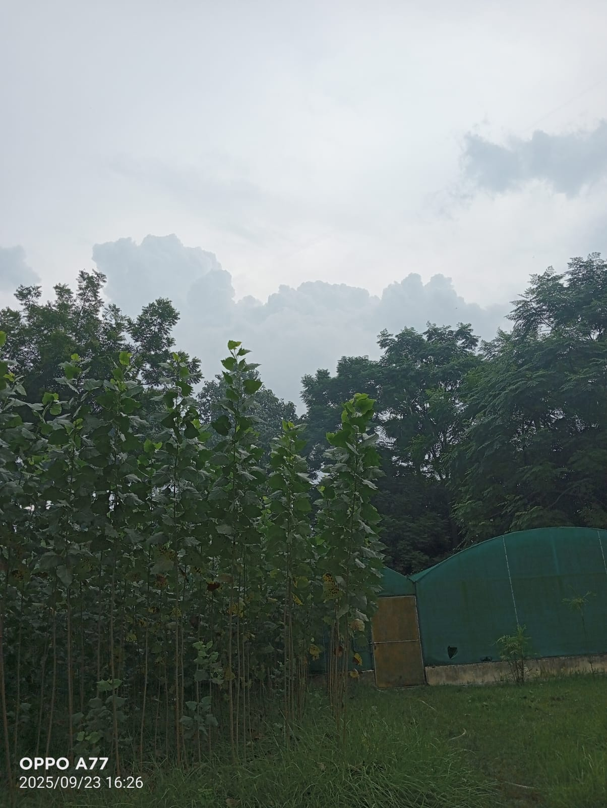
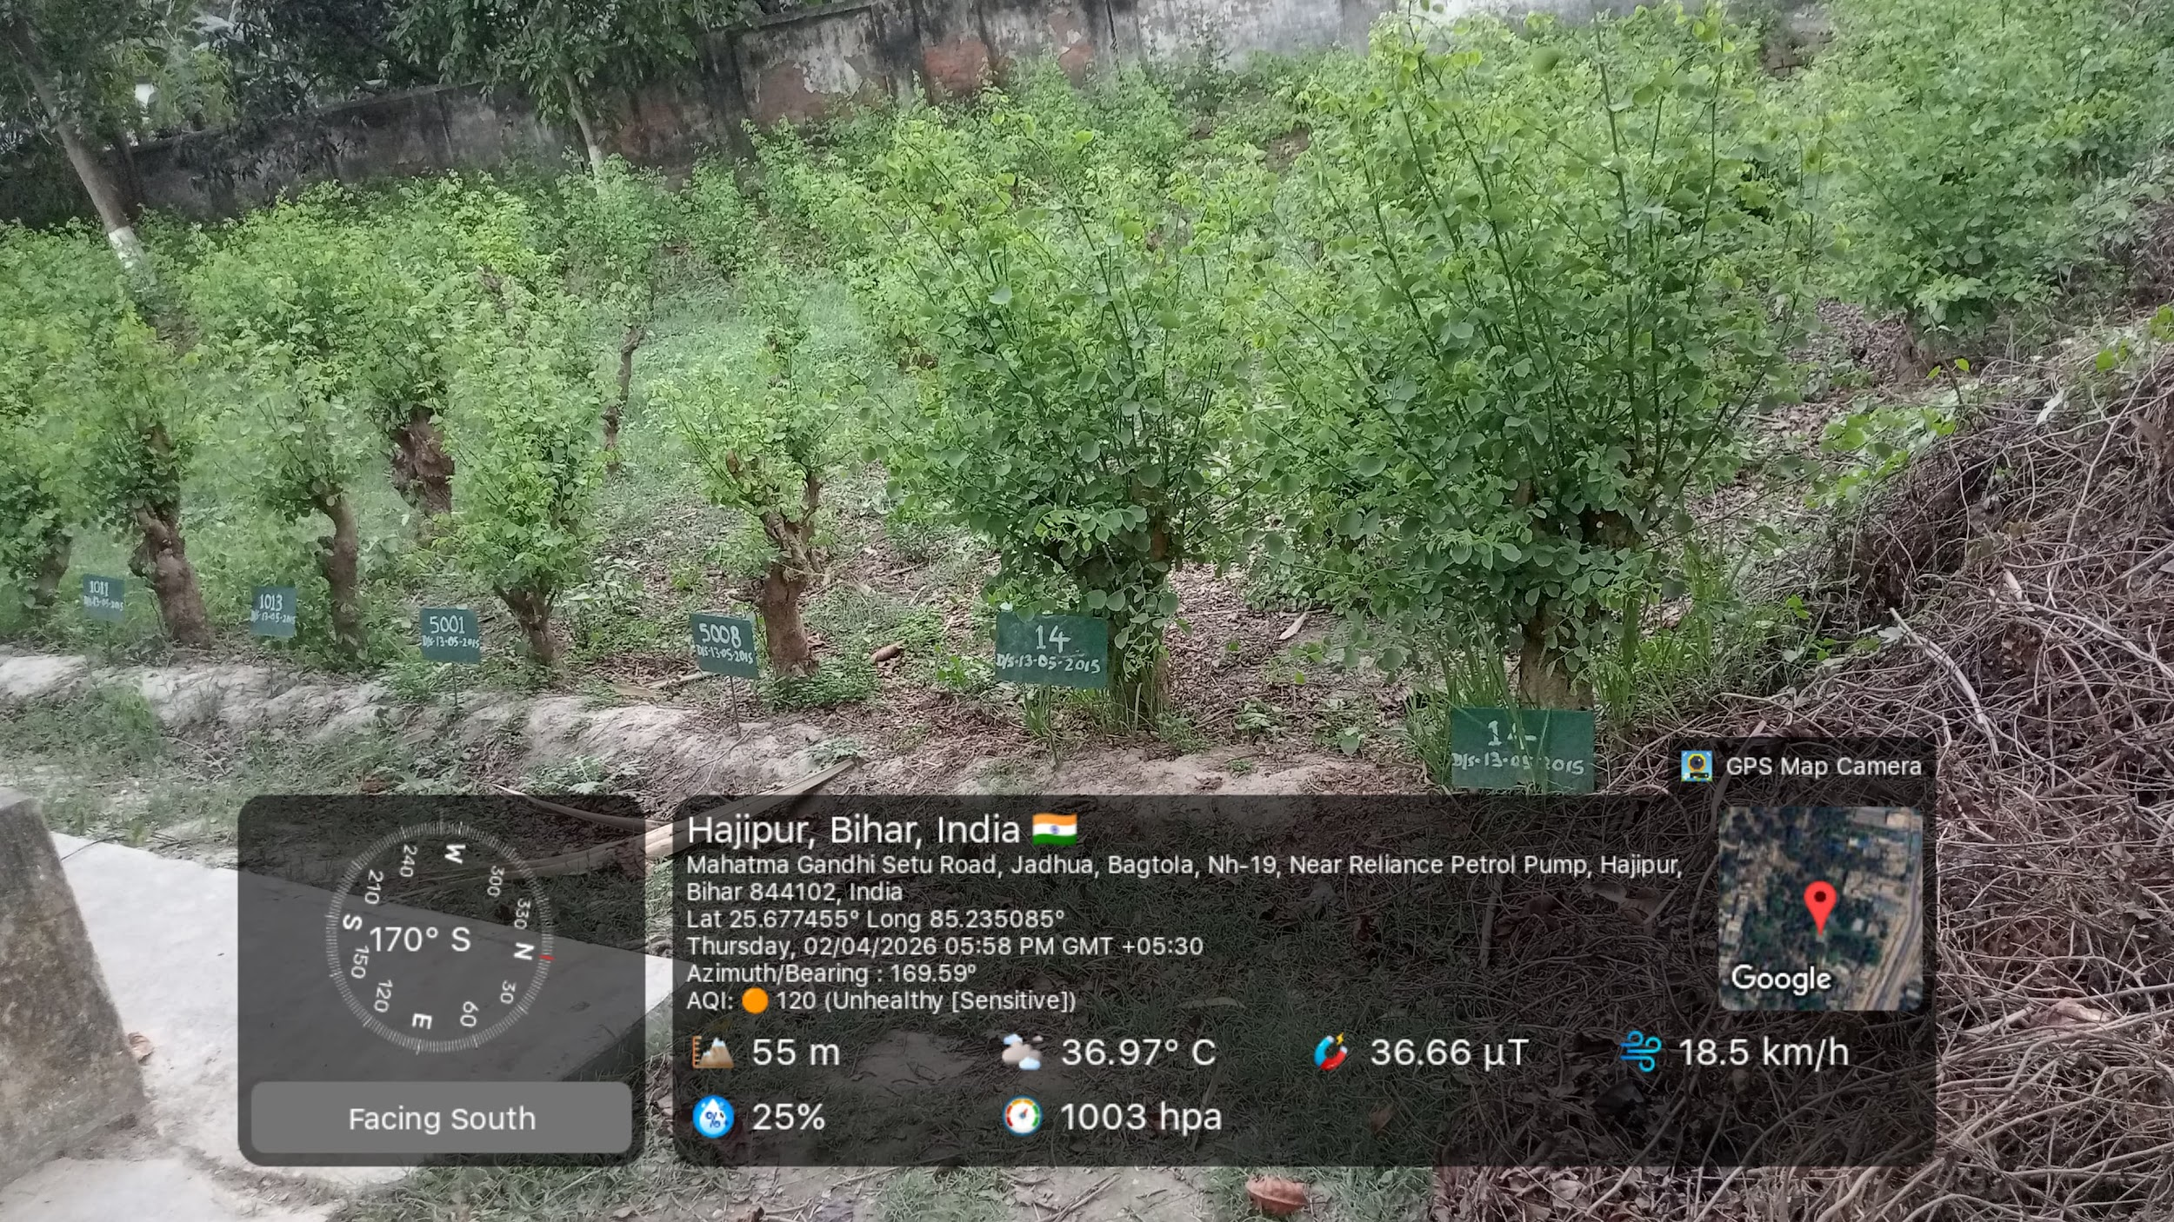
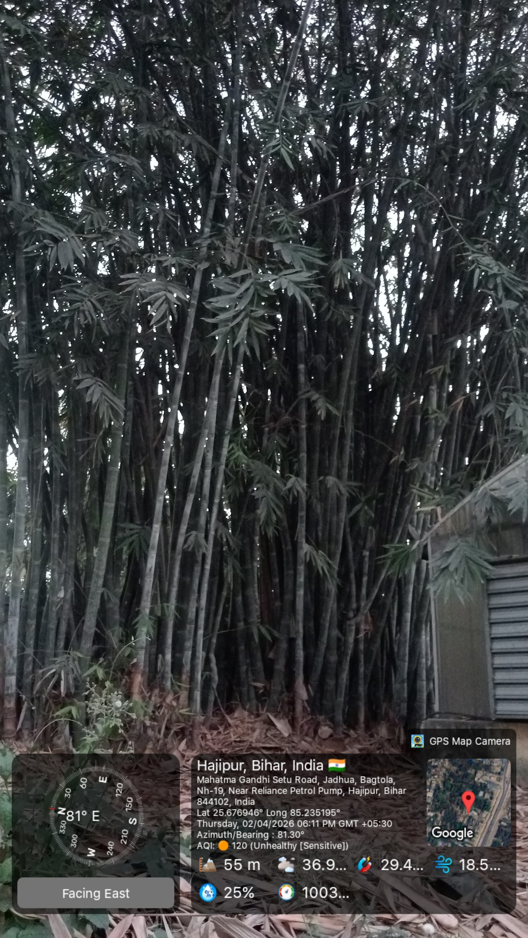
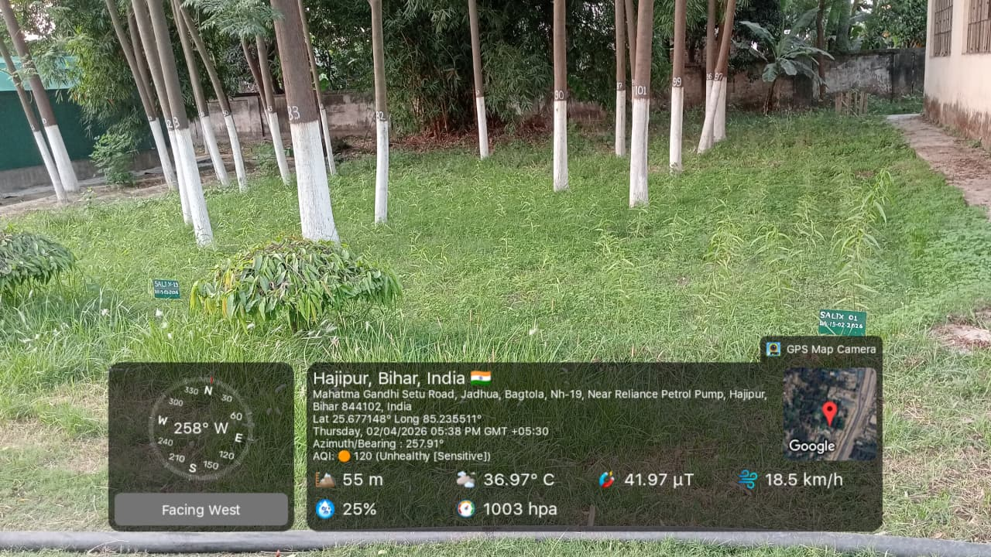
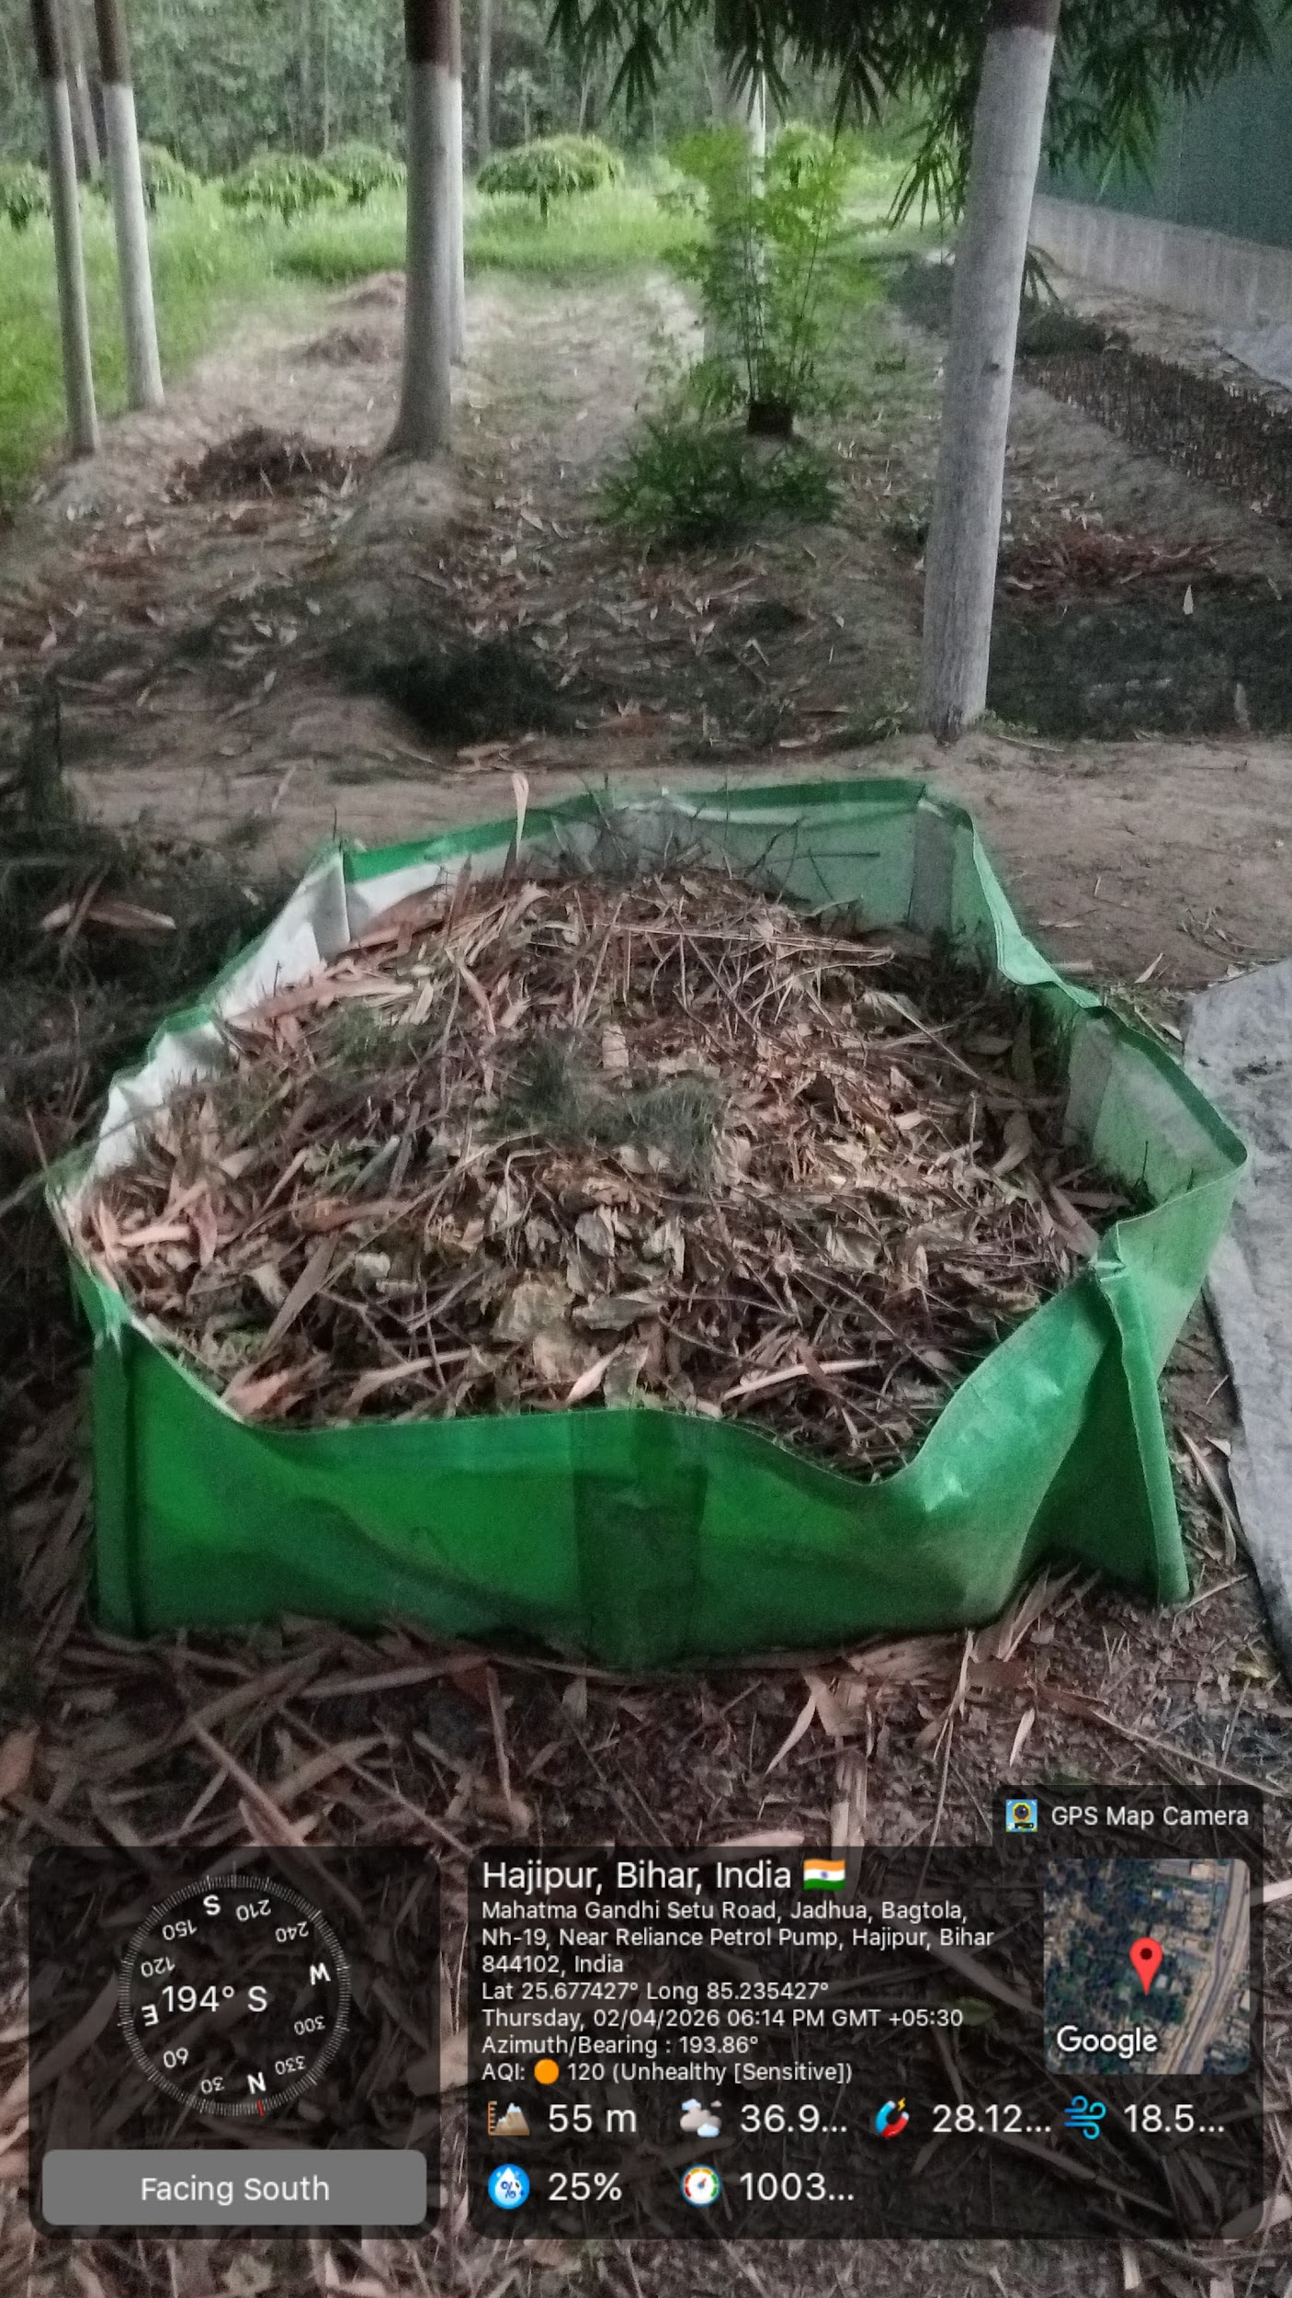

4.3 Nursery Development
The station also operates as a high-tech nursery, producing quality planting material for farmers and stakeholders.

Current Nursery Species
- Poplar
- Salix
- Rudraksh
- Bamboo
- Shisham
- Casurina
- Melia dubia
- Kadam
- Gamhar
- Semal
- Medicinal plants
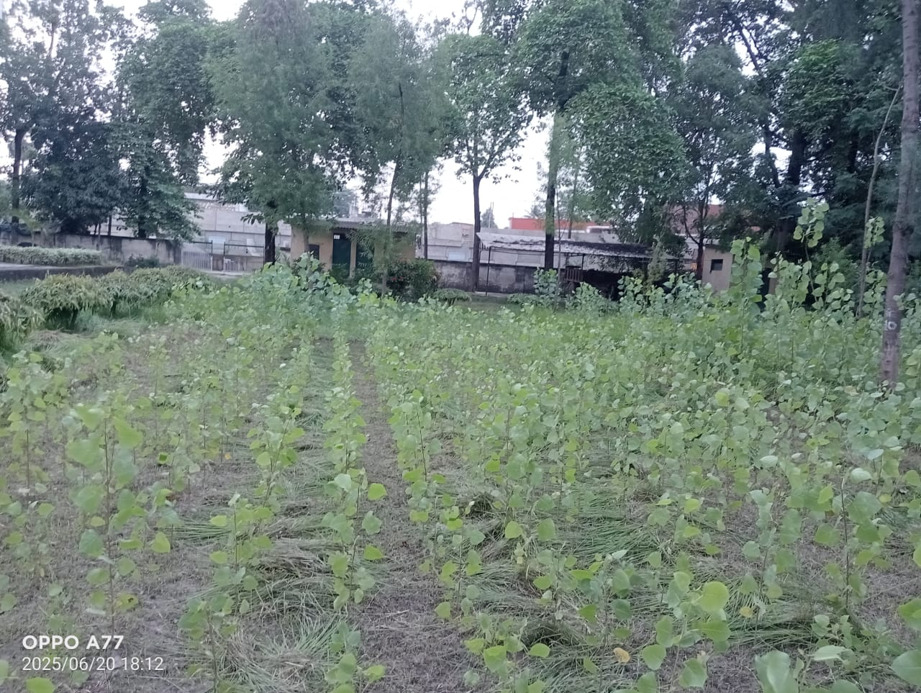
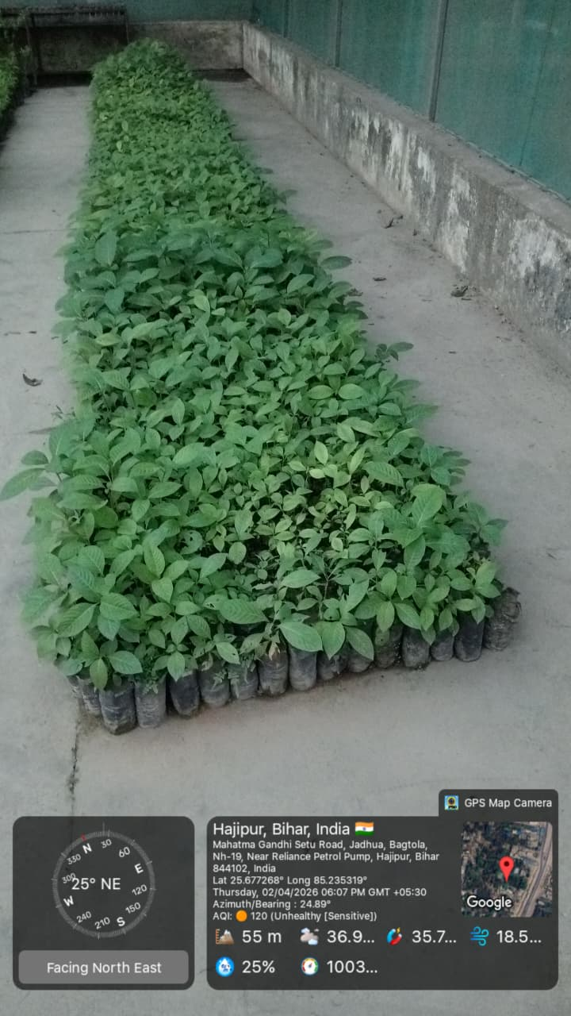
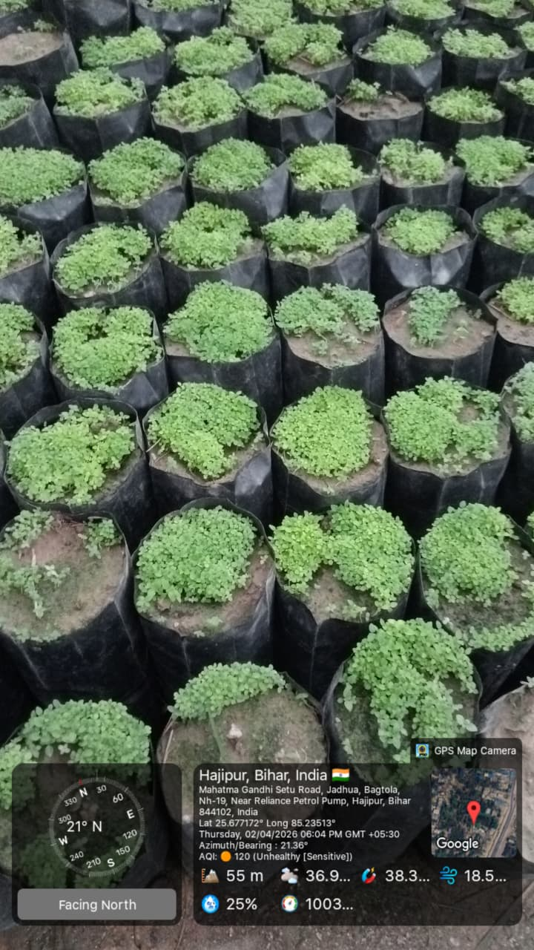

4.4 Farmer Training and Extension
- Organizes training programs for farmers.
- Participates in awareness campaigns and field demonstrations.
- Disseminates knowledge on modern agroforestry techniques.

4.5 Role as Van Vigyan Kendra
As a Van Vigyan Kendra, the station:
- Acts as a knowledge hub for forestry practices.
- Bridges the gap between research and field implementation.
- Provides technical guidance to farmers and stakeholders.

5. Infrastructure Facilities
The station is equipped with essential infrastructure to support research and nursery operations:
- Two-storeyed office building
- Two mist chambers (for propagation of plants under controlled humidity)
- Four hardening chambers (for acclimatization of seedlings)
- Common Bamboo Facility Centre
These facilities enable efficient plant production, research experimentation, and training activities.
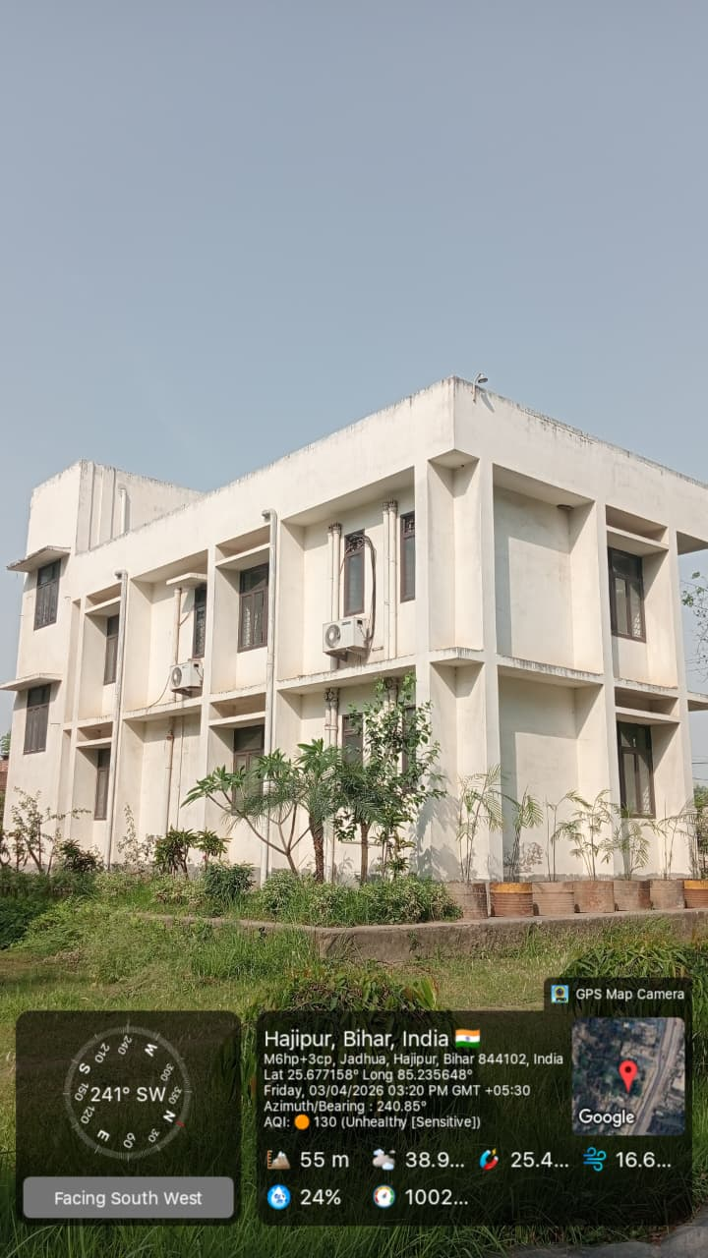
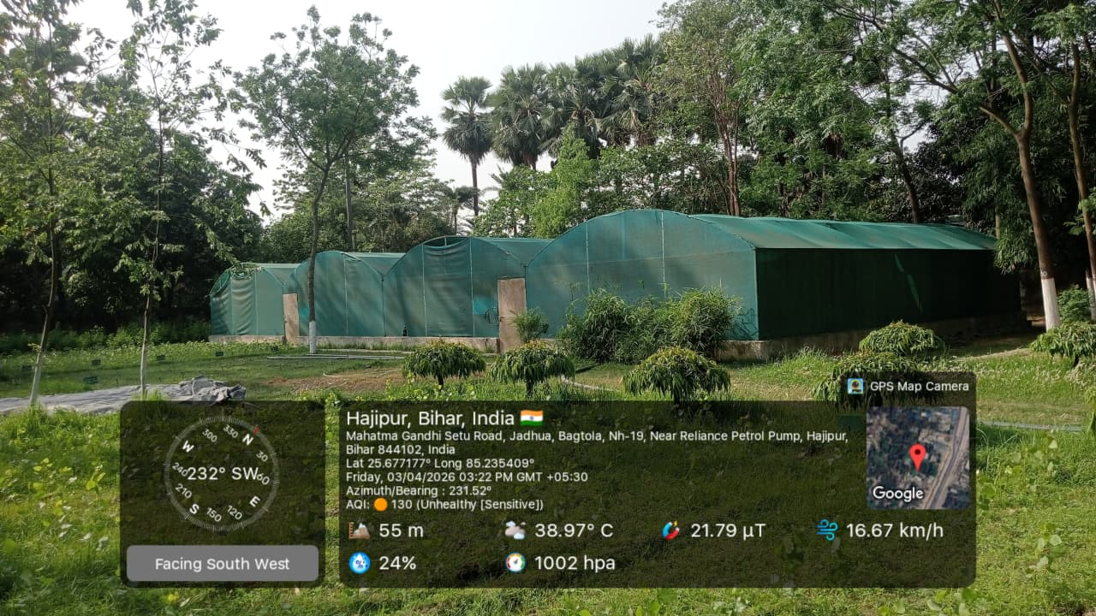
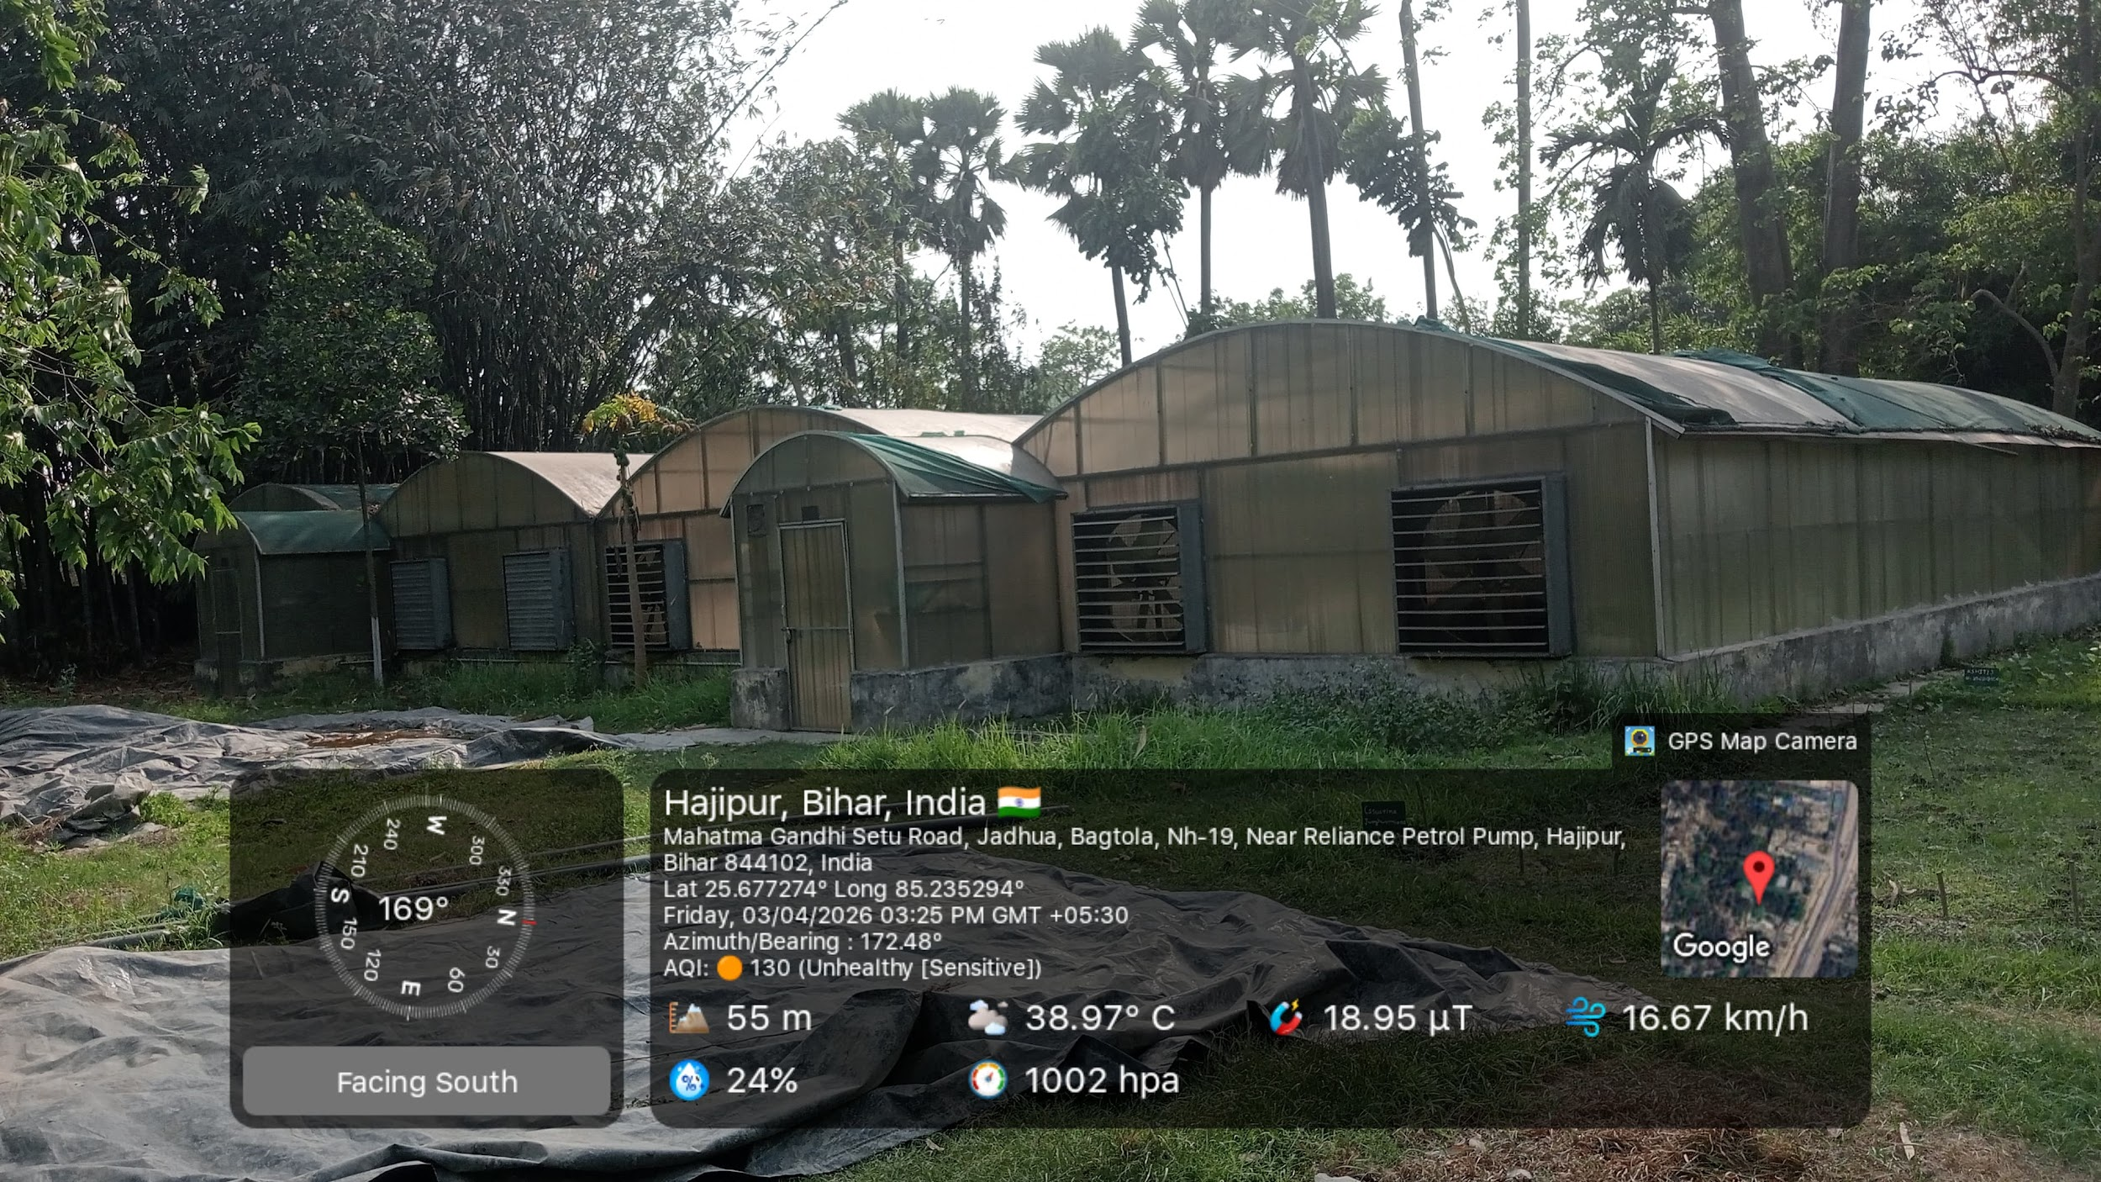
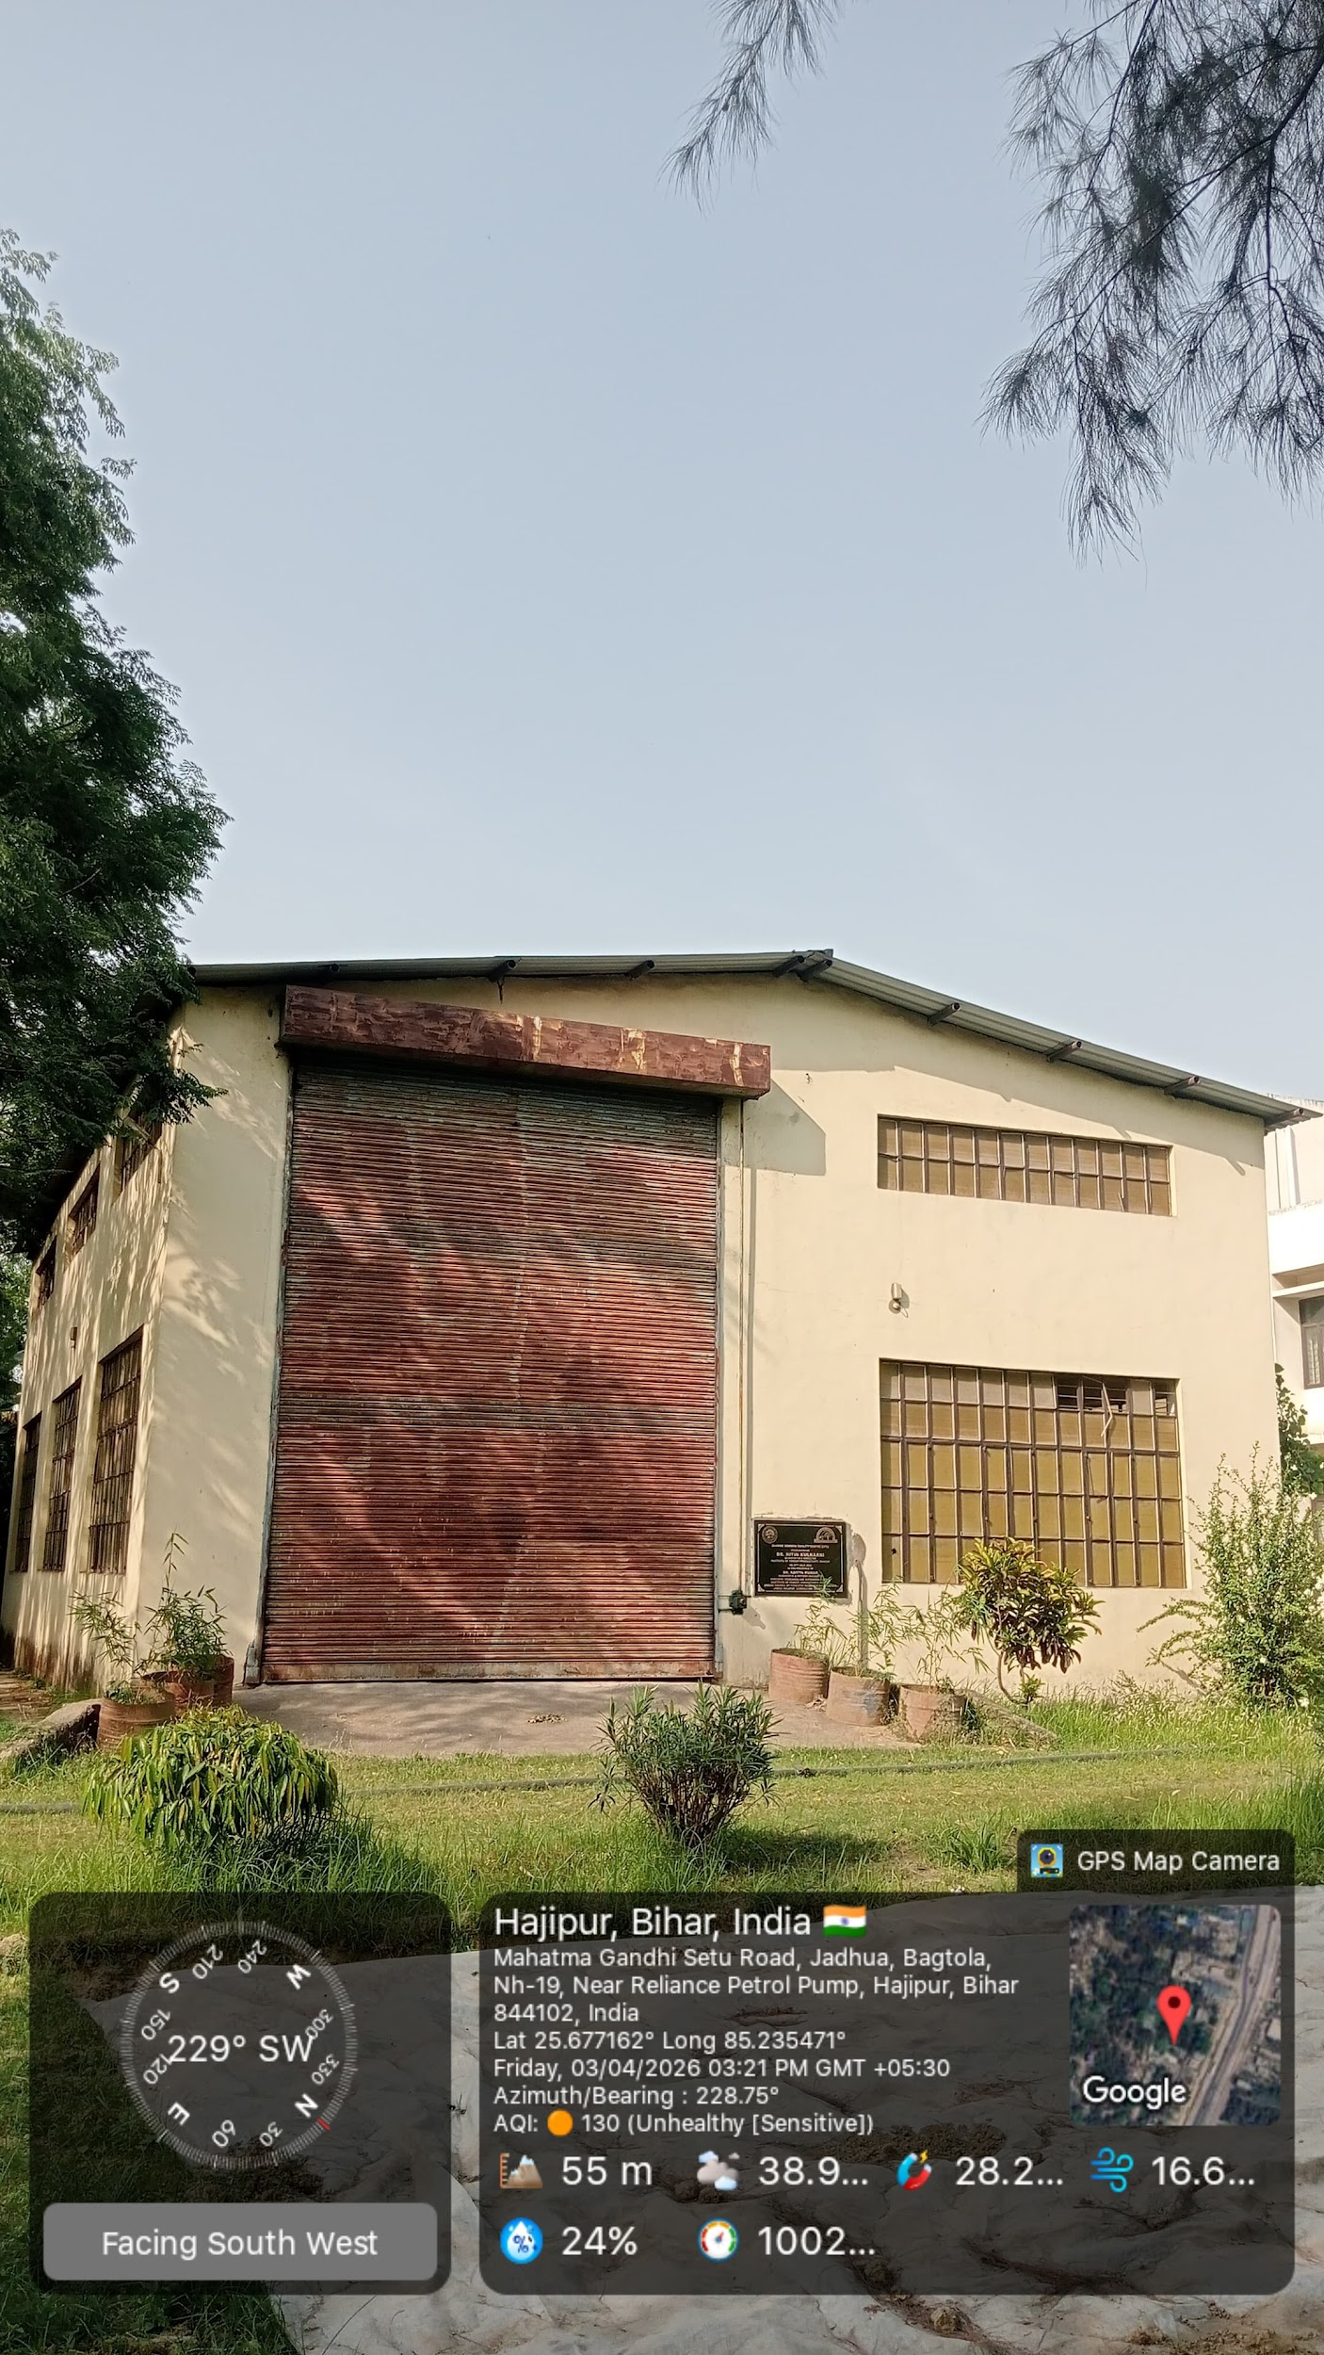

6. Human Resources
The research and technical activities of the station are supported by the following staff. Their work includes nursery management, research support, and coordination of training programs.

- Mr. Sanjiv Kumar – Senior Technical Officer
_____________________________________________________

- Mr. Hiridesh Shankar Vidyarthi – Technical Assistant

7. Significance of the Station
The Agroforestry Research Station, Jadua Hajipur aims in:
- Enhancing farmers’ income through diversified farming systems
- Promoting environmental sustainability
- Supporting afforestation and conservation efforts
- Strengthening rural livelihoods in Vaishali district
Its work in popularizing species like poplar and bamboo has contributed to both economic and ecological benefits in the region.

8. Conclusion
The Agroforestry Research Station, Jadua Hajipur has evolved from a project-based extension centre into a significant institution for agroforestry research and development in Bihar. Through its dual role as a research station and Van Vigyan Kendra, it continues to support farmers, promote sustainable practices, and contribute to the broader goals of forestry conservation and rural development.

